TRAYE Annual Report 2021:

Introduction:

Totnes Rural Area Youth Engagement (TRAYE) has been delivering community youth work and developing opportunities for young people in rural communities in South Hams and Teignbridge for the last 6 years. Our work uses various methods of engagement ranging from, open access youth clubs, project work, such as environmental activities, our “Youth Can Make a Difference” Forum, outreach, and street-based work and 1:1 support for those identified as most vulnerable.
During 2021 we have engaged with 517 young people and have carried out research with young people and their families, to develop an informed, needs based approach to delivering our much-needed work. Our key strength is our assertive approach to delivering youth work in the communities where young people live, which is fun, educational, and engaging.
Mission - TRAYE provides rural youth work in an inclusive and connected way, reaching out to the areas of Rattery, Buckfastleigh, Staverton, Dartington, Totnes, Harbertonford and Marldon. Working with young people aged 8 - 19 years old, we will promote kindness, compassion and respect at the heart of the work we do.

Vision - TRAYE’S vision is to advocate for young people, to help them have a strong voice in their communities. To promote health and wellbeing, kindness and creativity, fun and new opportunities for young people, so that they may reach their full potential and create positive changes in their own lives and the world around them.

Once again, the project has gone from strength to strength over the year. Our sessions have continued to adapt throughout the pandemic, and we have found ways to create safe and vibrant spaces where we as a team we have developed more opportunities for young people to access social education, friendship, and fun.

TRAYE Team:

Over the last 6 years, TRAYE has grown our team of Youth Workers has changed. We now have seven part time staff and as you will see in the table below, we have a wealth of talent in the team and between us we have over 60 years of experience creating opportunities for social education for young people in the communities where they live.
Name: | Position: | Qualifications:
Kerry McCabe | TRAYE Manager | BA Hons Degree in Youth and Community Work and has 22 years’ experience of leading and managing community-based Youth Work. Experience working with vulnerable families and substance misuse.
Laura Hamlyn | Senior Youth Worker | NVQ Level 2 Youth Work, currently studying Level 3 and has 3 years of experience working with young people and has taught Yoga and Mindfulness to young people for over 5 years.
Adele Marshall | Senior Youth Worker | Certificate of Education  Has 3 years of experience working with a wide range of young people with different abilities at Plymouth City College.
Nathan McCabe | Senior Youth Worker | Ba Hons Degree in Youth and Community Work and has 17 years’ experience leading and managing youth provision. Has worked for many years in the field of young people’s substance misuse and harm reduction
Sophy Creed | Youth Forum Worker | Ba Hons in Fine Art., BSc in Physiology, NVQ Level 3 in Youth Work has 10 years’ experience working with young people in community settings and has a strong focus on art therapy for young people.
Christian Murison | Youth Support Worker | Currently studying Level 2 in Youth Work and has 5 years of experience working with young people in alternative education settings. Is very keen to bring his years of experience working within the field of sustainability and ecology into his work.
Lucy Homer | Youth Work Assistant | Has completed Youth Work Traineeship, currently studying level 2 in Youth Work. Has volunteered in various Youth and Community Work settings for over 5 years.

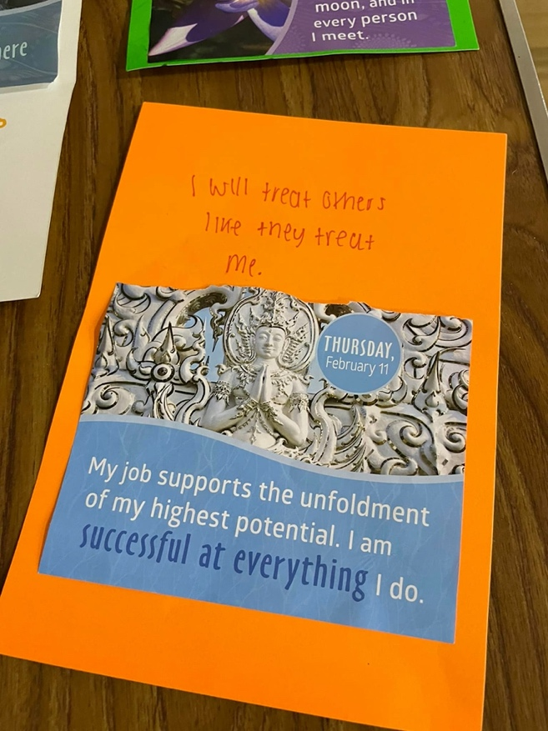

Project Breakdown:

Dartington Youth Club:

Lead worker: Kerry McCabe
Youth Support: Christian Murison
Age Range – 8 years +

Dartington sessions continue to happen every two weeks on a Wednesday evening and are delivered from the Dartington Village Hall, which is a large space with good facilities. Attendance has grown and we now have 65 members at the group. Usual attendance is around 18 young people each session.

We have delivered quality youth work, in line with our Yearly Programme Plan and the main highlights include various games and educational quizzes during the winter months, Christmas celebrations and a mix of outdoor games, sports and picnics in the summer months.

The young people also love to cook, and this gives us a great opportunity to work with them around healthy food, diet, and budgeting for food.

What young people and families have told us:

“It has helped me to make me more confident and I’ve made more friends” (Young person from Dartington)

“The fact the sessions are free and offer free food and drink to the young people is so important to me. Often, I am unable to afford clubs and activities for my son and sometimes I feel he misses out because we are on a low income. My son loves coming to Dartington Youth Club, he always comes home telling me what he’s learnt and how much fun he’s had.” (Parent/ carer – Dartington).
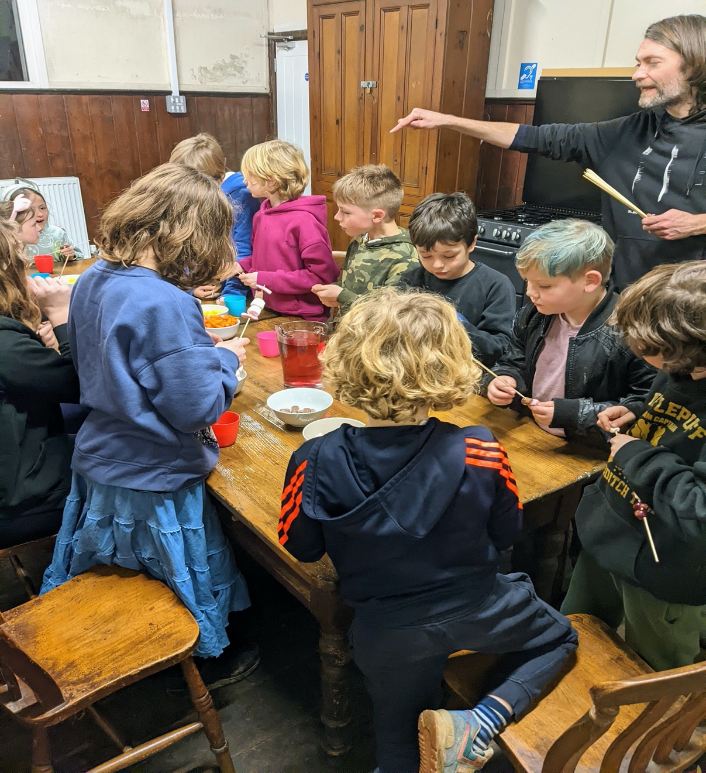

Staverton Youth Club:

Lead Worker: Laura Hamlyn
Youth Support: Adele Marshall
Age Range – 8 years +

Staverton Youth Club sessions take place on a Thursday evening and on a two-weekly basis, with sessions delivered in the Staverton Courtroom, Staverton Pavilion and Landscove Victory Hall. This enables us to reach more young people and offer a wider scope of activities and settings. Attendance at the session has fluctuated throughout the year, mainly due to many young people testing positive for Covid, but latest statistics show this area has 51 active members. Usual attendance sits around 12 young people each session.

Once again, in line with our yearly planning we have delivered activities such as Outdoor Education including nature walks, river swimming and outdoor ball games and picnics.

Social Issues are of real interest to this peer group. They are from a wide variety of backgrounds including young people from the travelling community, local young people and young people that have travelled from as far as Ashburton to attend.

What young people and families have told us:

“Yes, I love coming to youth club as I get to go out and see people which is a big change for me as where I live is off grid” (young person from Staverton)

“My son loves the youth club, and all the workers are absolutely brilliant with the kids. I am a single parent, and my son does not have siblings, we don’t have much family around, so the club is vital for his wellbeing. Thanks to everyone who makes it possible for my son to attend” (Parent/carer from Staverton).

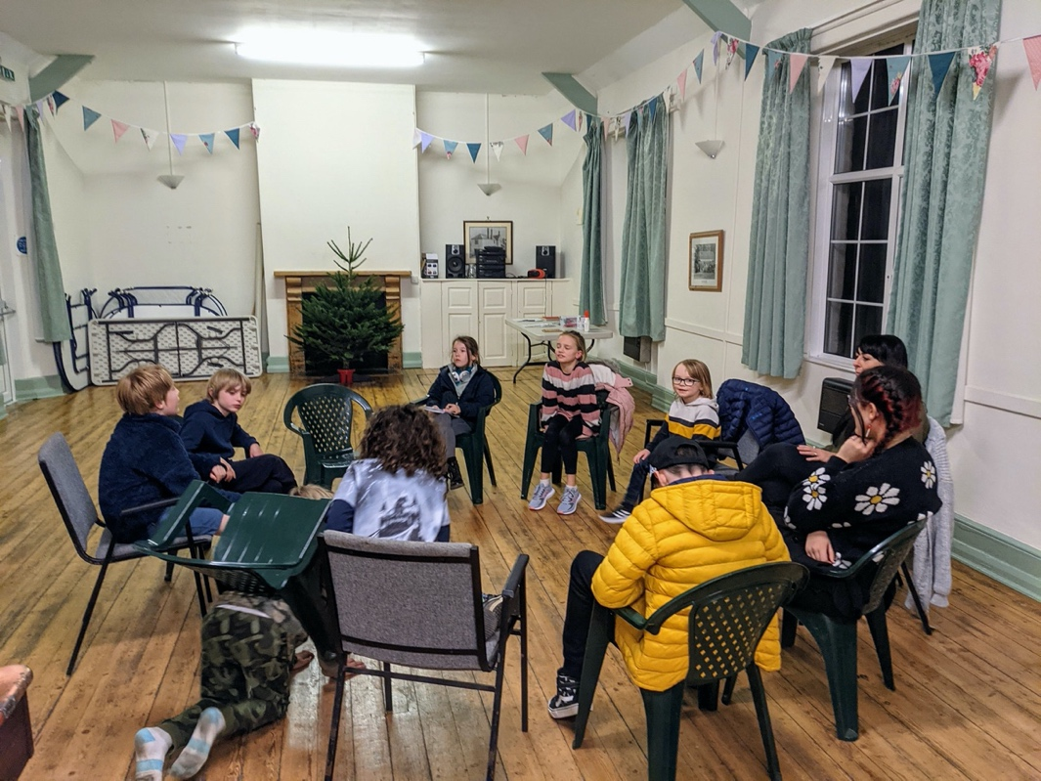

Marldon Youth Club:

Lead Worker: Kerry McCabe
Youth Support: Laura Hamlyn
Youth Assistant: Lucy Homer
Age Range – 11 years +

The Marldon Youth Club runs every two weeks on a Friday evening at the Marldon Village Hall. Attendance is steady and this area currently has 29 active members. We normally see around 15 young people at each session.

There is older age group that attends this Youth Club (12-16 years) and this has meant that we have been able to get into some really useful ‘Issue Based’ work with them. We have explored issues such as anxiety, mental health, self-injury (formerly known as self-harm) and awareness around drug and alcohol use.

It is clear that the young people enjoy getting together at Youth Club, they are a close-knit group, with many knowing each other from Marldon Primary school but losing touch when going to different secondary schools. It is wonderful to see the reconnection they make and the joy of togetherness of this club.

“Seeing my friends and relaxing is my favourite part of youth club, I get to see my friends more and forget about homework etc for even just a few hours” (Young person from Marldon)

“Very impressed with the Marldon Youth Club and want to thank everyone involved” (Parent/Carer from Marldon).

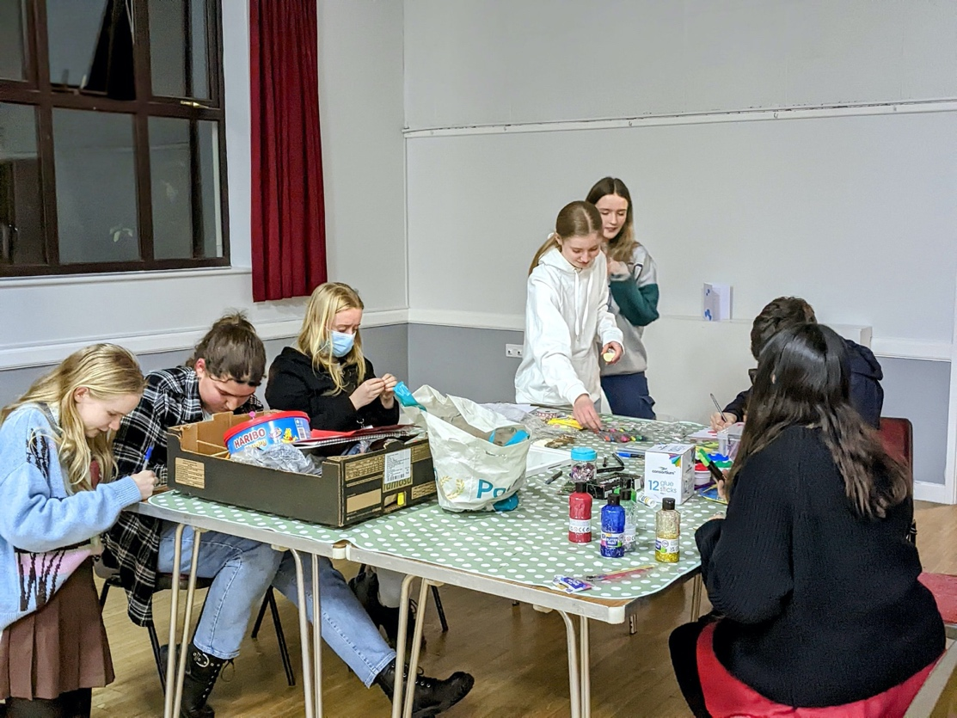

Rattery Youth Club:

Lead Worker: Adele Marshall
Youth Support: Nathan McCabe
Age Range – 8 years +

Rattery Youth Club runs every two weeks on a Monday evening at Rattery Village Hall. Attendance has recently grown and Rattery now has 24 active members. We usually see 12 young people on average at the sessions.

Young people have really felt the benefit of this project, saying they enjoyed it and have learnt new skills. There have been outcomes around improved confidence and better mental health – in terms of having new strategies to improve well-being. Also collaborating with each other and working together.

“Its just so much fun coming to youth club and seeing my friends, sometimes I don’t normally get to see them because of where I live – its pretty remote you see, and I can sometimes feel lonely” (Young person from Rattery)

“I think its great what you are doing at TRAYE, my daughters love coming and tell me all about it when I pick them up. I was really impressed with the work you did around the Chinese New Year. It’s just so important for children to be aware of the world around them” (Parent from Rattery)

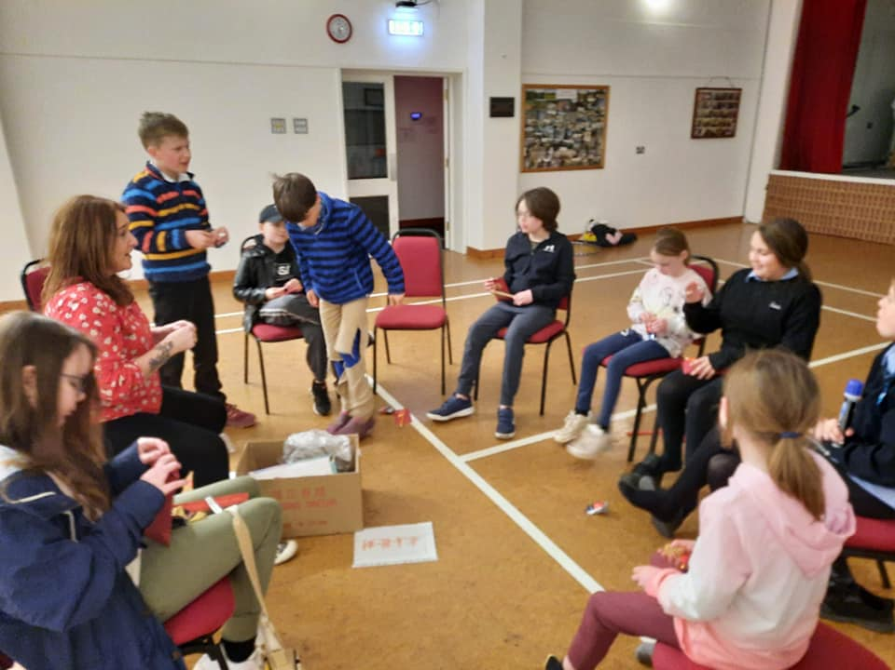

Harbertonford Youth Project:

Lead Worker: Laura Hamlyn
Youth Support: Adele Marshall
Age Range – 8 years +

Harbertonford Youth Project runs every two weeks on a Thursday evening at Harbertonford Village Hall. Attendance in this area took a dip after the pandemic but has more recently grown back to its usual 16 active members.

This is a fun and vibrant session, young people really seem to value this opportunity to socialise in safety, meet new friends and speak to the youth work team. The young people that attend are very creative and love to be involved in lots of arts and crafts-based activities. Also, we have regular music-based sessions, where a local young man brings his DJ equipment.

It has been really positive to be part of the young peoples’ recovery from the isolation of the Covid pandemic and watch them make new connections and see this session begin to flourish once again.

What young people have told us:

“Everything is great, there is nothing I would do to improve things, I learn new things every time and like to help others to learn and explore too” (young person from Harbertonford)

“We often struggle to provide fun things for our boys to do, sometimes they get bored and
argue with each other. On club nights, they are so much more relaxed and cheerful and I would like to say thank you for the free trips you have given to us” (Parent from Harbertonford).

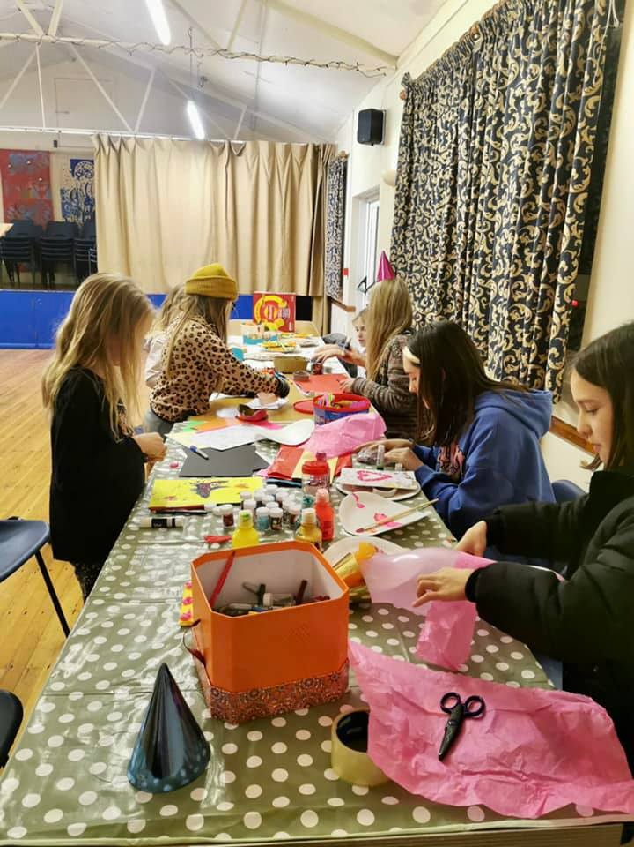
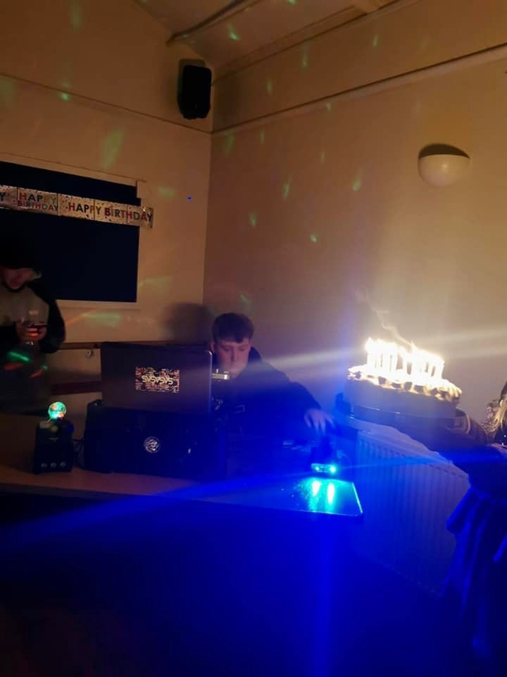

Buckfastleigh Youth Wellbeing Café:

Lead Worker: Laura Hamlyn
Youth Support: Adele Marshall and Nathan Mccabe
Age Range – 11 years +

The Buckfastleigh Youth Wellbeing Café offers a holistic programme of sessions to young people aged 11 -19 years. The delivery of this project includes weekly youth work sessions on a Wednesday evening. At the beginning of the year, we firstly reached out to young people via outreach, street-based youth work, and secondly we brought young people together as a group when Covid-19 restrictions allowed. The session has 71 active members with an average of 25 young people turning up to each session.
This group changed venues in September and now uses the Inspire Interventions building on Old Totnes Road. This space is kindly donated to us rent free and is very young people friendly, drawing large number of young people most weeks.

“The sessions are fun, and the activities are good, cooking new stuff every week like food from all around the world”. Other comments were, “being able to rely on the worker” and another told us; “it has changed my life” (Young person – Buckfastleigh).

“I want to say how invaluable the Café is to the young people in our town. Since it first started, I’ve watched it grow, progress and expand to bring so much positivity into the lives of those who attend” (Parent – Buckfastleigh)

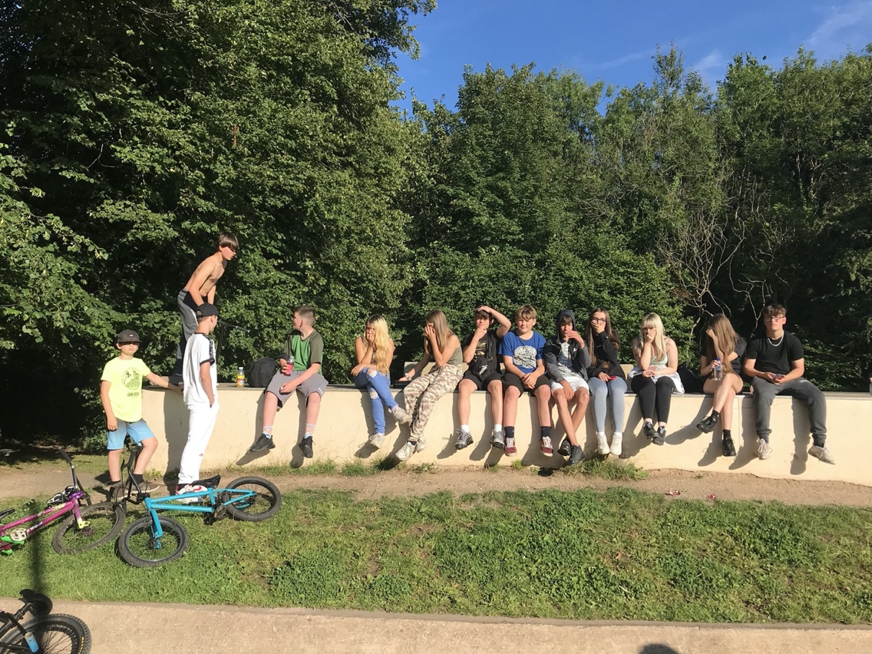

Youth Can Make a Difference Forum

Lead worker – Kerry McCabe
Youth Support – Sophy Creed
Youth Assistant – Lucy Homer
Age Range – 11 years +

Over the year, the Youth Can Make a Difference Forum has grown considerably. The Forum is now our largest group within TRAYE with 76 active members in total. In April time, the Forum began talking about some of the barriers that they face living in rural areas and felt strongly that we needed to apply for funding to alleviate this issue:
‘We love where we live and want to help. We want to see more opportunities for young people and their families living in South Devon. Many young people struggle to find work, access colleges in the big towns and cities and we want to see those opportunities available in our small villages and towns. Transport is always an issue for young people and some of us don’t have the confidence we need just yet’.
The young people of the Youth Can Make A Difference Forum (April 2021).
In August 2021, TRAYE were given funding from the National Lottery to take this idea forward:
- To ensure young people are heard. Participation is a prerequisite of empowerment and creating the spaces for young people to explore their lives and be heard is a vital component allowing us to move beyond a tokenistic approach.
- That young people take part in decisions that affect their lives. Helping young people to become decision makers in their lives is the first step to authentically improving self-esteem and confidence.
- To create safe spaces for young people to explore their feelings, thoughts and wishes.
- To develop young people’s capacity to care for each other and support them to value this as a key life skill.
- To increase access to volunteering, training, and paid work opportunities.
- To increase employability for young people and work readiness.
- To increase access to existing community support, such as partner organisations, local activities and community events helping young people to become more actively involved in the life of their community.
This project began in September 2021 and will continue until September 2024.
The Youth Can Make a Difference Forum continue to take action in their communities, most recently donating food to the Totnes Food Bank and discussing issues such as inequality and discrimination.

“Being able to talk about things I can’t normally. I feel a lot safer there to talk about things and I feel we do actually make a difference as a group” (Young Person from the YCMAD Forum).

“I feel so proud of my daughter being part of this group. She’s always been strong minded and the fact she can now take action is wonderful. I love seeing what the group is doing collectively on Facebook, these young people are truly phenomenal” (Parent/ Carer of young person from YCMAD Forum).

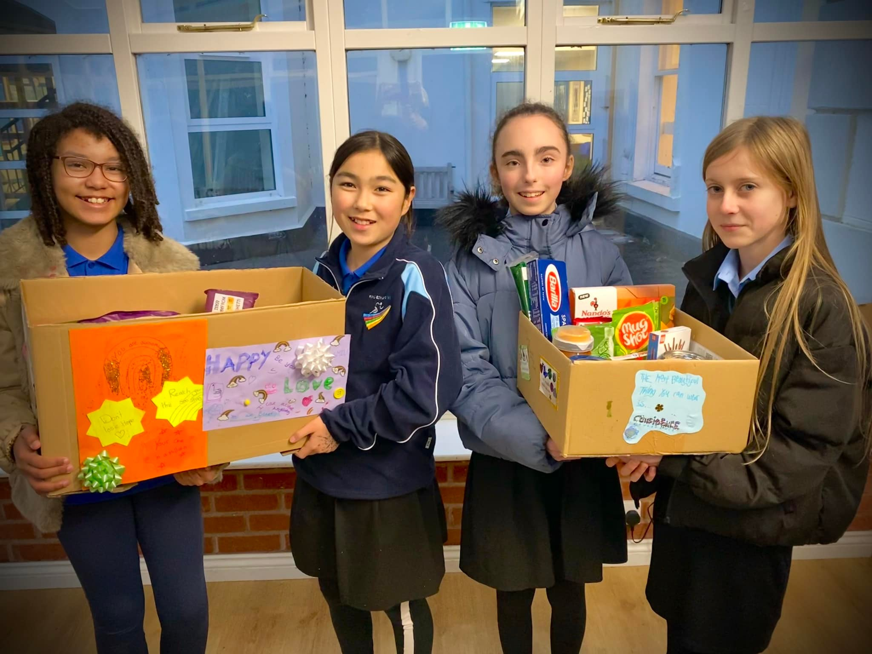

Consultation Work:
Through consulting with the young people who regularly attend our provision throughout the year and using the rich data we received in our 2021 surveys, we have ensured that the TRAYE Project offers:
- Free food and drink at all our sessions, such as hot chocolate, milkshakes, smoothies, pasta bake, curries, toasted sandwiches, jacket potatoes and sweet options such as banoffee pie, fruit salad and cake. Most of the food is made from scratch by young people supported by youth workers.
- A safe space to relax and meet friends, with games, quizzes, and educational activities to get involved in. We have continued to talk to young people about the current issues that are affecting their mental health and wellbeing.
- Free trips and activities are available if needed and take place during school holiday times, as well as sports and fitness such as Non-Contact Boxing, Yoga, Basketball, Swimming and Cricket.
- Sessions continue to take place on a two-weekly basis, except for Buckfastleigh Youth Wellbeing Café, which runs weekly. Sessions are generally held in Village Halls, although the Buckfastleigh session is held at Inspire Interventions and the Youth Can Make a Difference Forum is held at Kennicott Library.
- We continue to offer one to one support to young people who need extra help outside of the sessions and continue to refer young people and their families onto services such as Foodbanks, Social Services, Post 16 Education and Early Help.
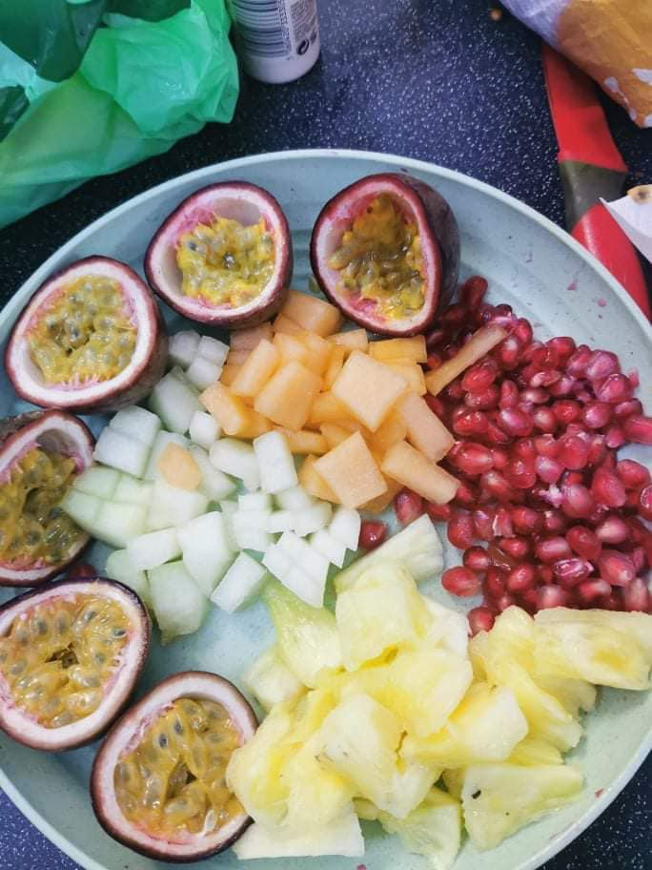

Session Themes:

Through regular Needs Assessments in our sessions, Team and Lead Workers Meetings, the Youth Workers continue to plan and co-ordinate the delivery of the TRAYE Programme. This has meant that we now have a common educative thread running across all of our sessions and that at every point in the calendar there is a joined-up project such as our “Round the World” cookery project or our “Heart to Heart” Project (please see below) where we recognised the people we love and feel inspired by. This linked-up delivery across all areas has enabled us to share resources across the project as a whole. This feels like a real step forward for TRAYE as we professionalise and grow as an organisation.

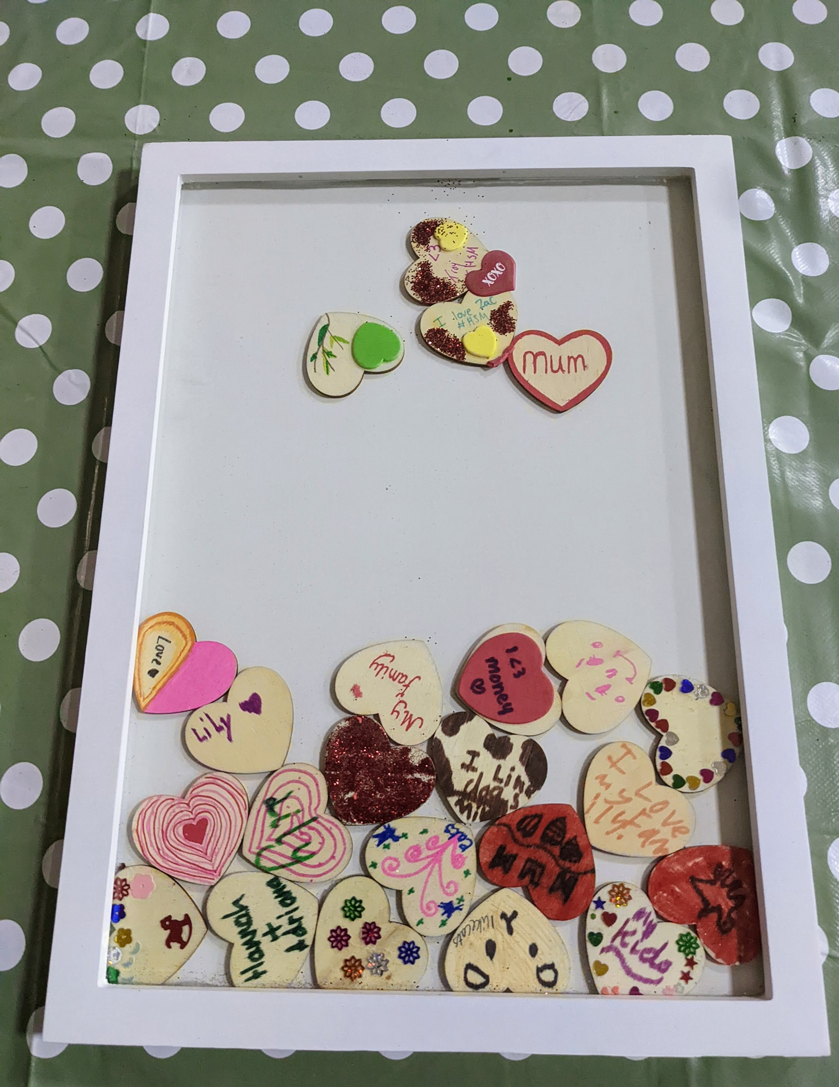

Trips and Activities:

Throughout 2021 TRAYE completed 18 different trips across the year, these included:
Tree planting, various Radio shows, a Permaculture Day, a trip to the Rare Breeds Farm, Non-Contact Boxing, partnership work with Participate Arts, 5 x outdoor sessions with the Totnes Living Projects, Quay West, Woodlands Leisure Park, a Skate Park event, Exeter Winter Wonderland and Bowling.

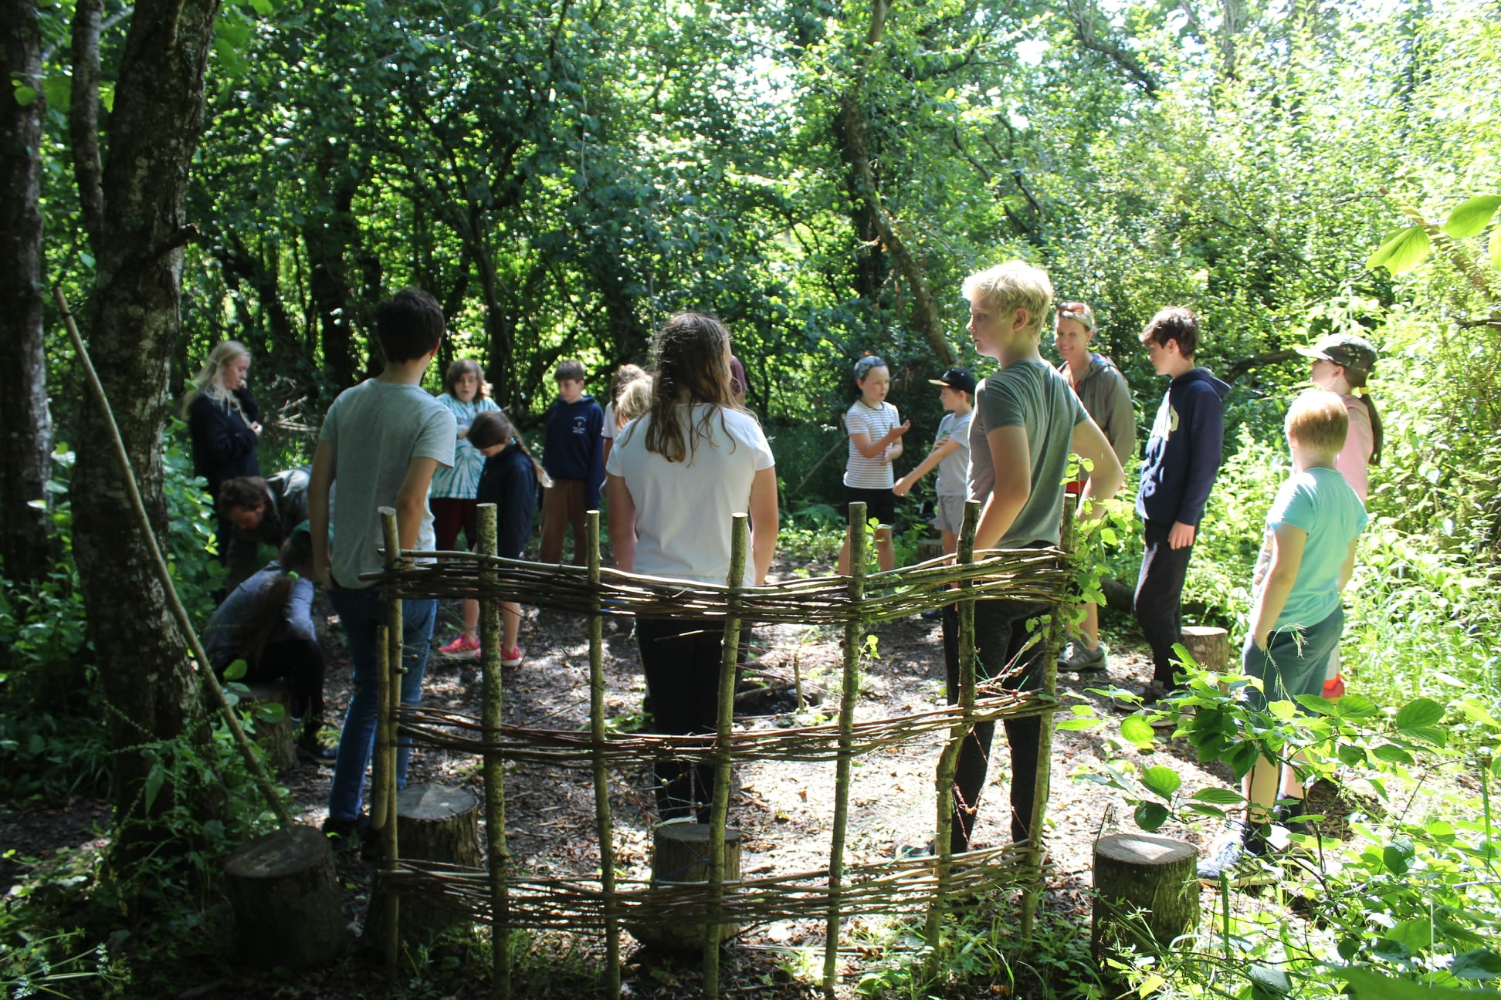

'Living projects was my favourite of all the summer activities, it was more fun, i enjoyed making fires, telling stories around said fires and jumping in the river' Young Person

'I would definitely like TRAYE to do more sessions with the Living Projects, my son enjoyed them so much and I feel it was really good for his mental health, being outside and learning about nature.' - Parent

Outreach/ Detached Work:

From January 2021 until July 2021 TRAYE continued to offer Outreach and Detached Youth Work which was fully funded by the Youth Endowment Fund. This funding enabled us to continue reaching out to young people when we were unable to meet in a youth club setting due to the pandemic. In this period, we made contact with 174 new young people.

Young Bank Youth Workers 2021:
At the beginning of 2021 we employed Erin, Olivia, Emilie, Imogen and Lucy as Young Bank Youth Workers. They completed a Youth Work Training Programme and then went on to work on our sessions learning valuable Youth Work skills. Some moved on to higher education in the summertime, but Lucy has continued with TRAYE, completing a Traineeship in Youth Work (please see below) and she has now become a Youth Work Assistant for TRAYE.

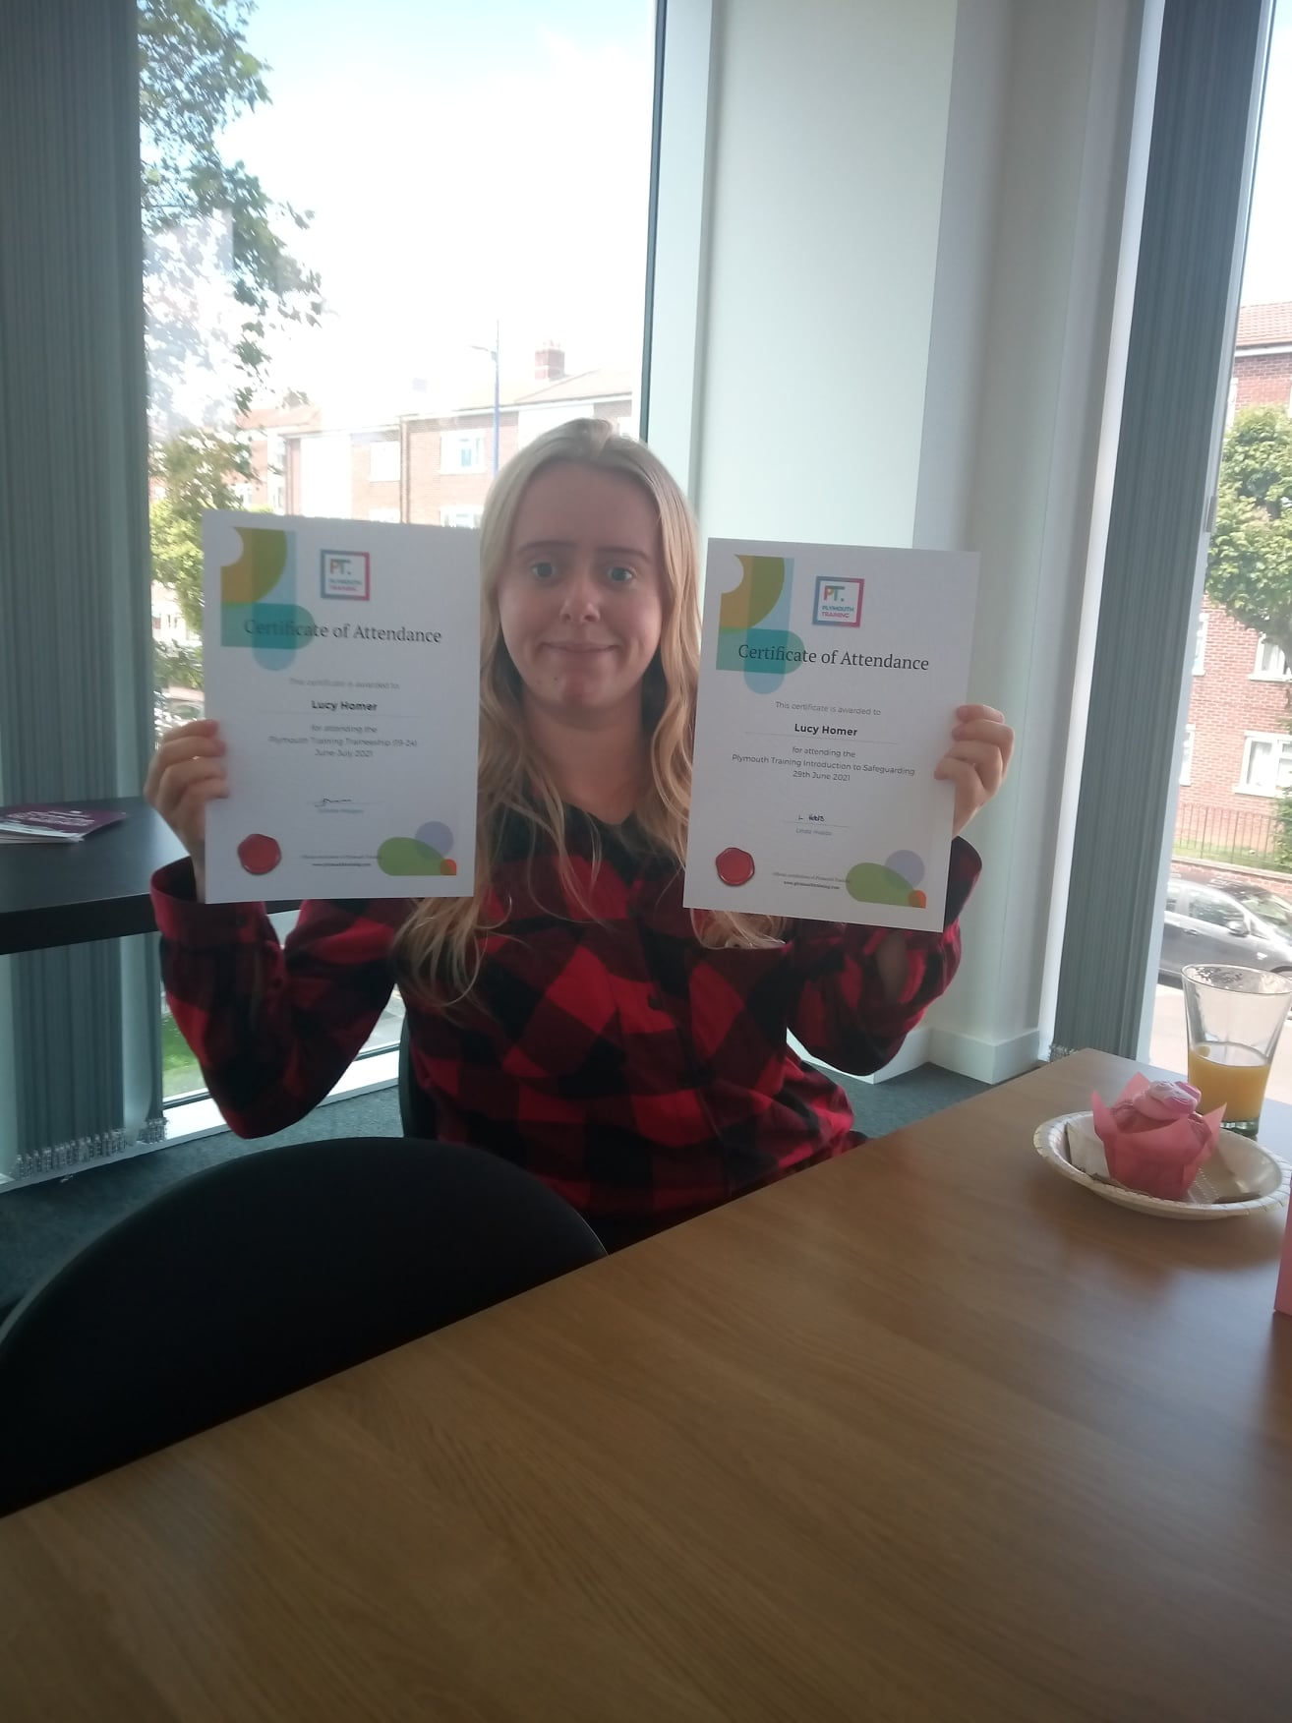

In November 2021, we employed four new Bank Youth Workers – Isabella, Albie, Loui and Odin These young people are currently completing their training and are looking forward to working on the TRAYE sessions during 2022.

All our Young Bank Youth Workers are aged between 16 – 25 years old and have had positive experiences of community youth work throughout their lives. Many have been part of TRAYE since the beginning and have continued to grow with the project and are keen to support the services they once used. We feel privileged to be able to attract young people from a varied mix of backgrounds and to have them as part of the TRAYE Team.

“
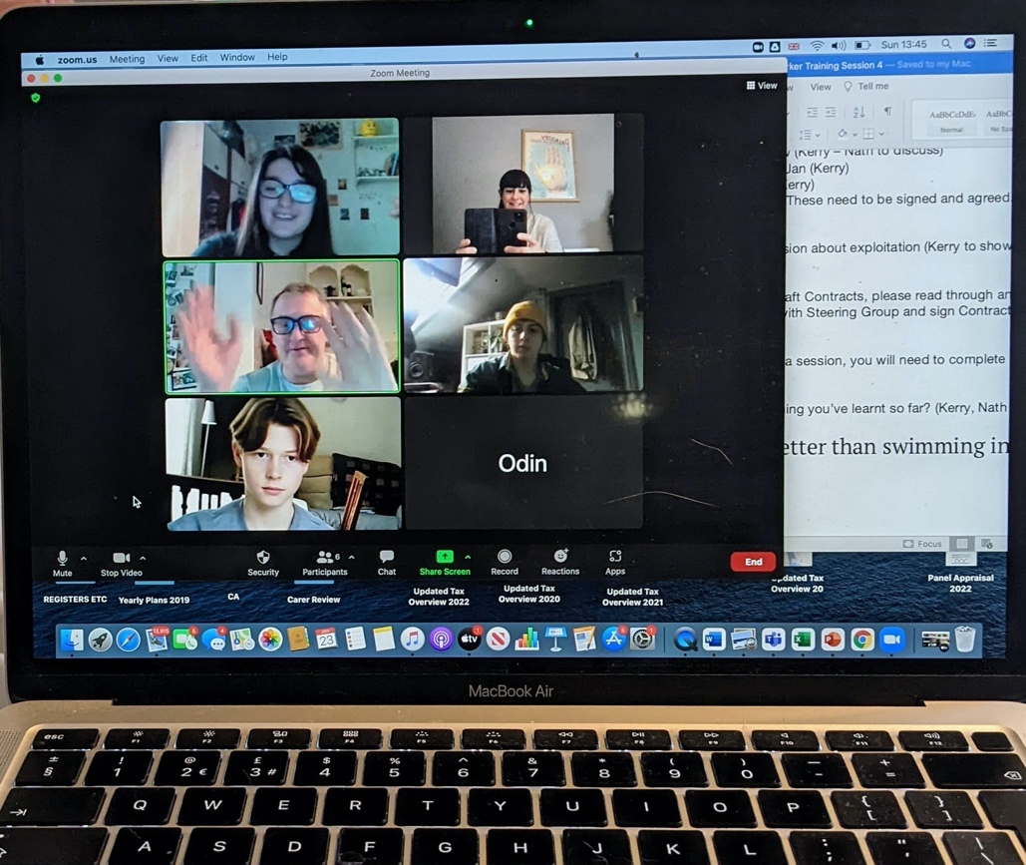

Work Experience:

In December time, TRAYE offered Work Experience to two young people, Katie and Eva from South Dartmoor School. Katie and Eva enjoyed their week at TRAYE, learning about Youth Work, being part of an Interview Panel and supporting many Youth Clubs. Katie said:
“Work Experience was really fun. It has really helped me see how confident I can become. At the start of the week, I was really nervous, but by the end of the week I didn’t want the week to end. Thank you to everyone at TRAYE for giving me and Eva this chance”.

Statistics:

Area: | Contacts 2021: | New Contacts 2021: | Total:
Rattery | 22 | 2 | 24
Buckfastleigh | 28 | 43 | 71
Staverton | 36 | 15 | 51
Dartington | 38 | 27 | 65
Totnes (YCMAD Forum) | 30 | 46 | 76
Harbertonford | 16 | 0 | 16
Marldon | 25 | 4 | 29
Outreach/ Detached | 81 | 93 | 174
Young Bank Youth Worker and Young Volunteers | 11 |  | 11

Total number of young people reached over 2021: 517

Changes and professionalisation of TRAYE:

In November 2021, we were able to offer both permanent employment contracts and Zero Hour contracts to all our youth work team. This has been a very positive move for TRAYE as a whole and has ensured we have become more professional. This does however increase our core costs and we are working continually to secure funding to ensure the continuation of our growing offer.

What the young people hope to achieve in 2022:

We asked the young people to think about what topics they would like to know more about, they told us:
“Drugs”, “mental health”, “race”, “discrimination”, “social issues” and “gangs”
When asked about trips and activities, young people told us they would like to:
“Go to the cinema”, “more non-contact boxing”, “sleepover” (mentioned twice) and “getting out and about in a different area”, “more Pondfields and Tree Planting”, “Quay West and Woodlands”, “Meals out” and “to Learn to Cook”.
Another young person said, “games aren’t necessary, having someone to trust is.”

The Youth Can Make a Difference Forum came up with these ideas below:
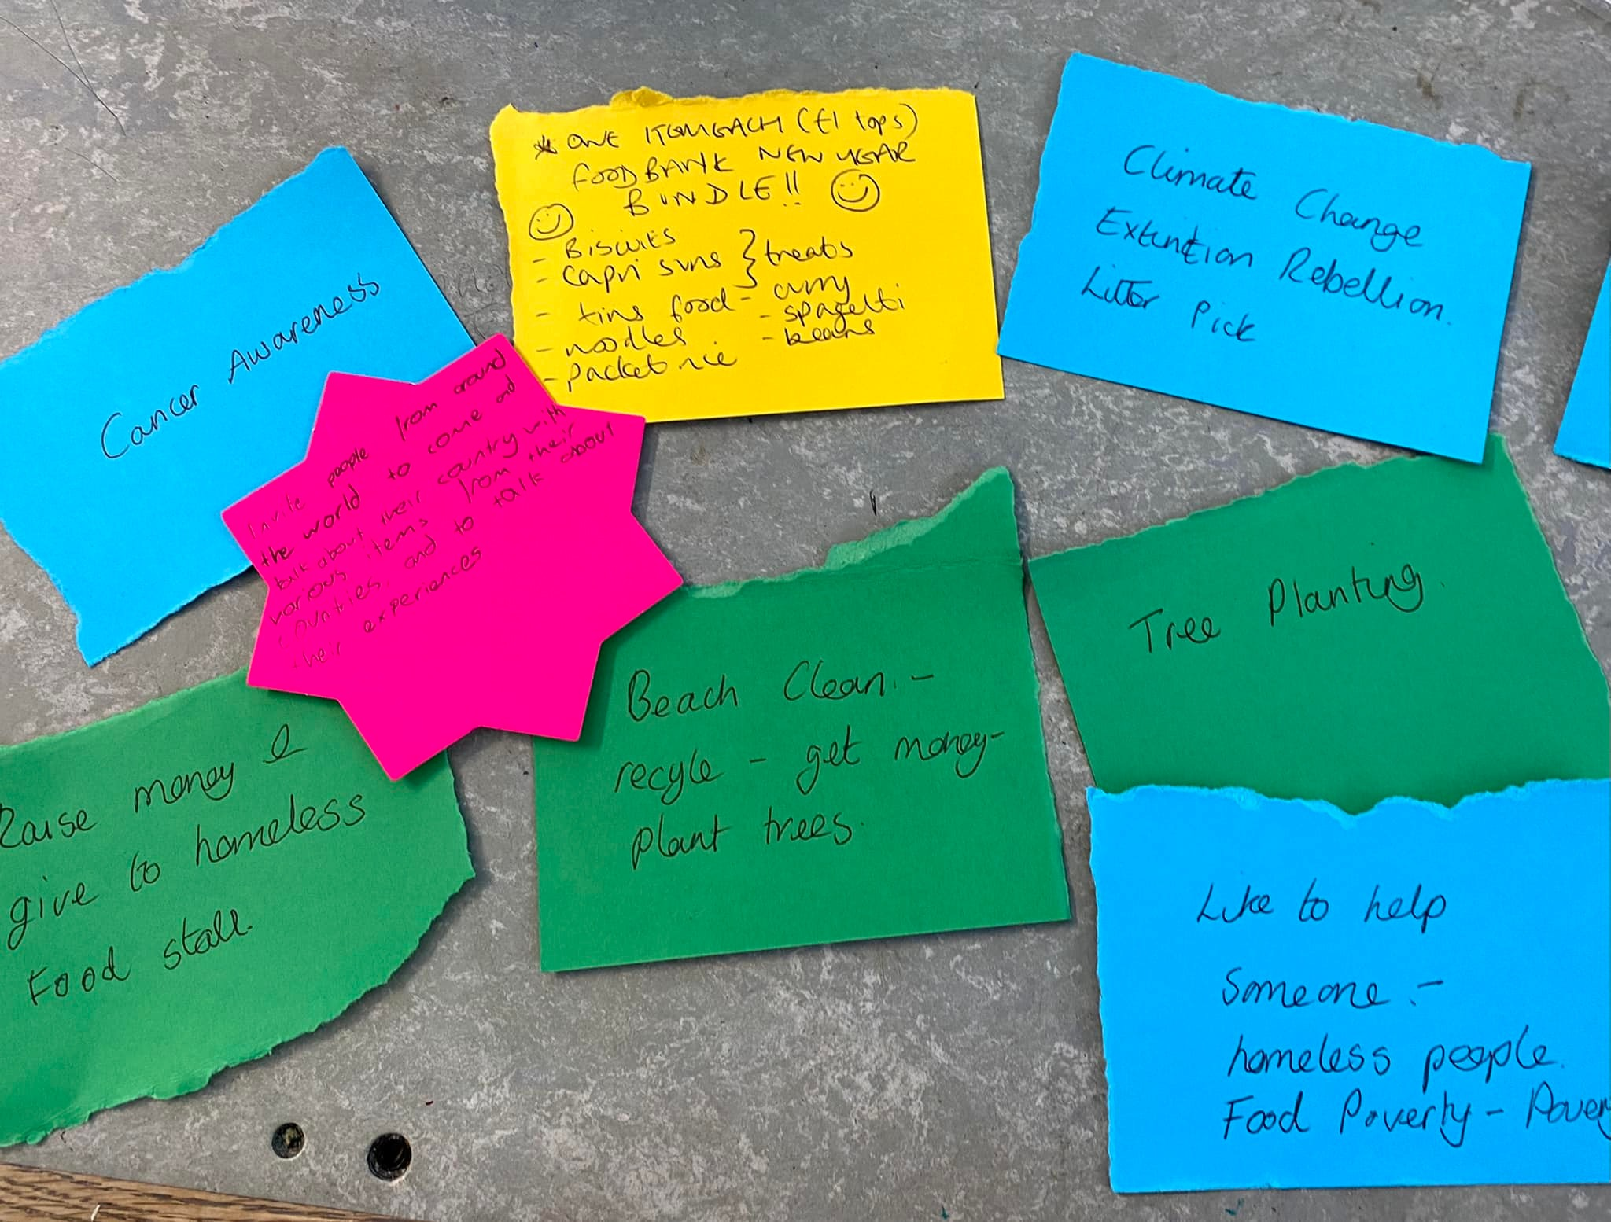

Where do young people see TRAYE in 5 years’ time?
“See it running smoothly and it having lots of support“

“Even better food, more food. Just food”

“Ummm the same?”

“Still running”

“Have its own building”

“Bigger and better”

“Sustainable, resilient, reaching more and more young people”

“Still going!”

“Global”

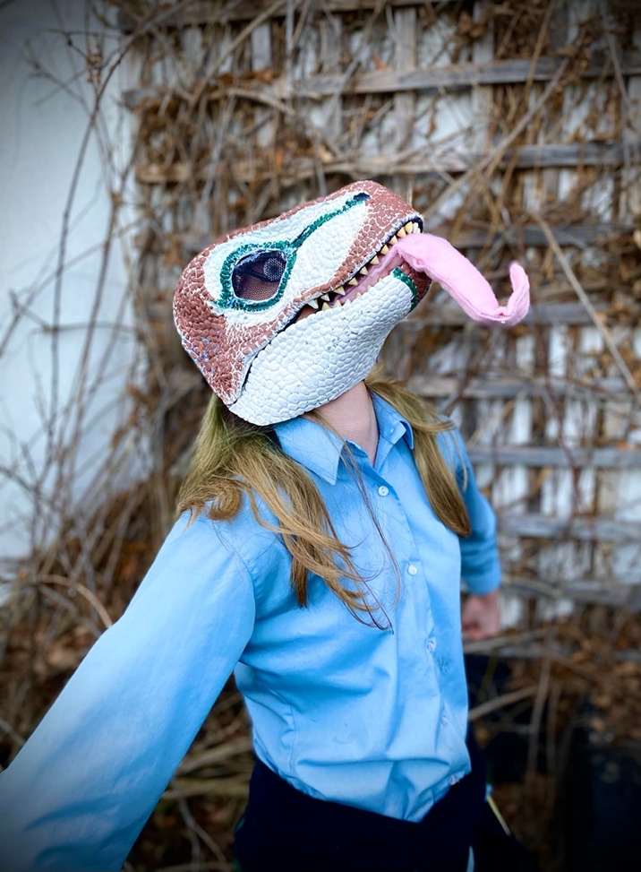

The TRAYE Team would like to thank the young people and their families for their continued support over the year. We would also like to say a huge thank you to the TRAYE Trustee’s, Steering Group and our Funders!

What Youth Work Can Do! - Impact Report

Hi my name is Alyssa and I’m 15 years old. I’ve been going to Buckfastleigh Youth Wellbeing Café for over a year now and really enjoy it. The recent project that we did around loneliness and isolation really helped me to see how important it was to come to youth club, to see the youth workers and to learn new skills. When Covid came along I was very lonely, particularly during Lockdown. I had my family, but we found it really tough and at times and I felt really down.

Here’s me making cottage pie at Buckfastleigh Youth Wellbeing Cafe:
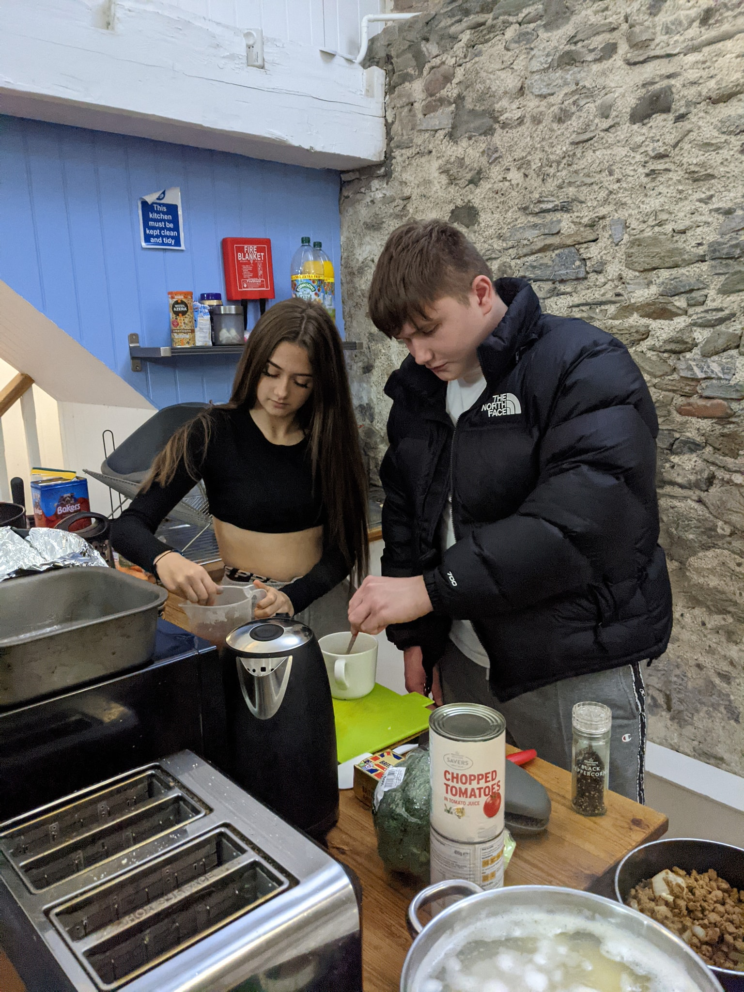
Coming to Buckfastleigh Youth Wellbeing Cafe has really helped me, I’ve started volunteering, setting up the youth clubs, bringing activities to the sessions and cooking from scratch. I’m a young carer at home, so learning to cook has helped me learn new skills that I now use at home. I’m feeling much more confident in myself, this project has helped me feel happier. The photo below shows the young people enjoying the cottage pie I made:
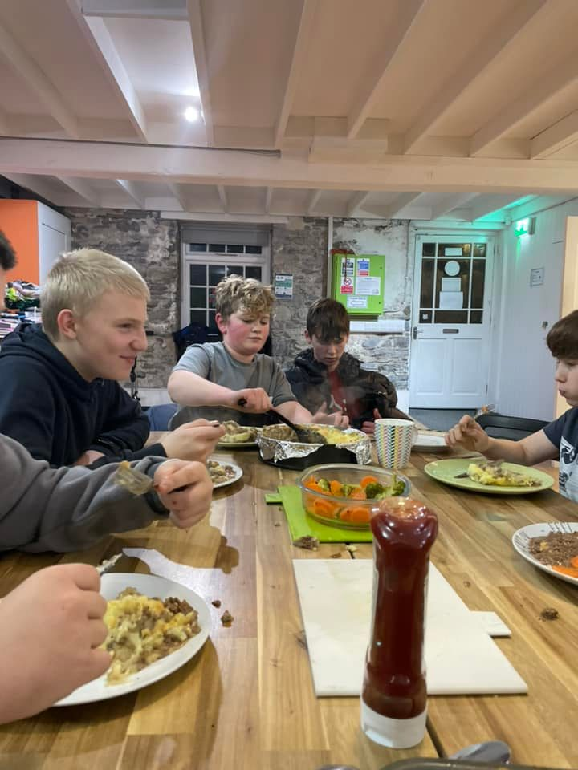

I feel this project needs to continue as it brings the young people of Buckfastleigh together and helps them to have fun and learn new things.

I’ve learnt so much over the last few months, mainly it’s been around well-being and gratitude but also how a youth club runs. I didn’t realise all the work that went into running a youth club! I love being part of the planning of things and bringing my ideas to the youth workers as they listen to me. I’ve also learnt how to cook cottage pie, curries, banoffee pie and pasta bake, all from scratch.

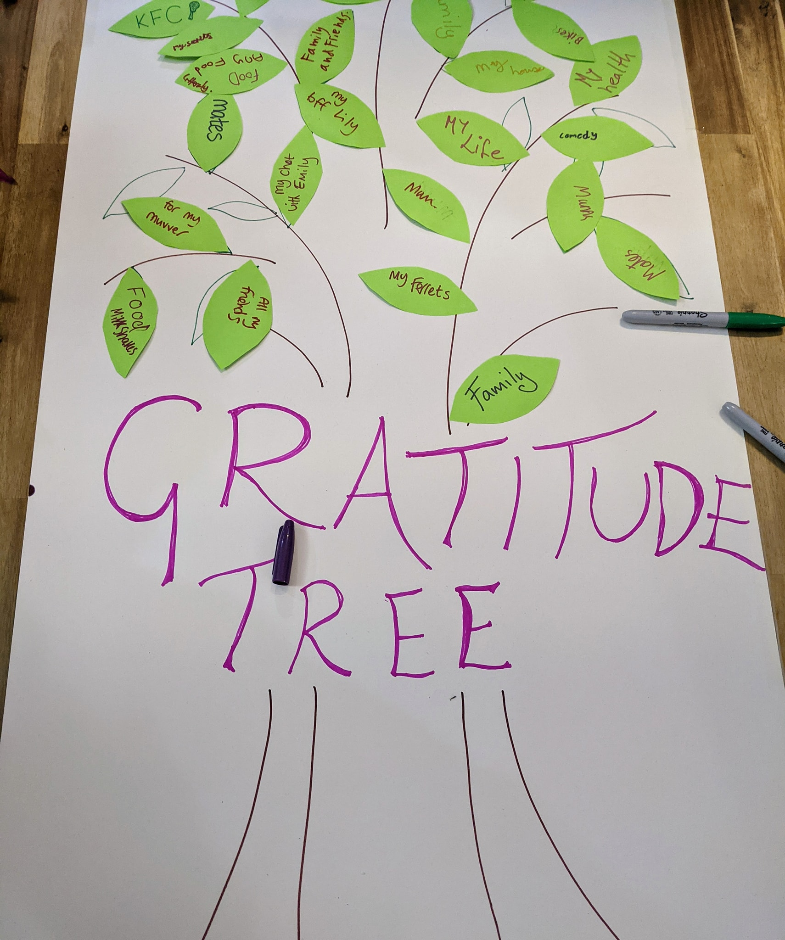

Here is a photo of us all talking to our youth worker Nathan about what makes us happy and what we can do each day to make ourselves feel better.
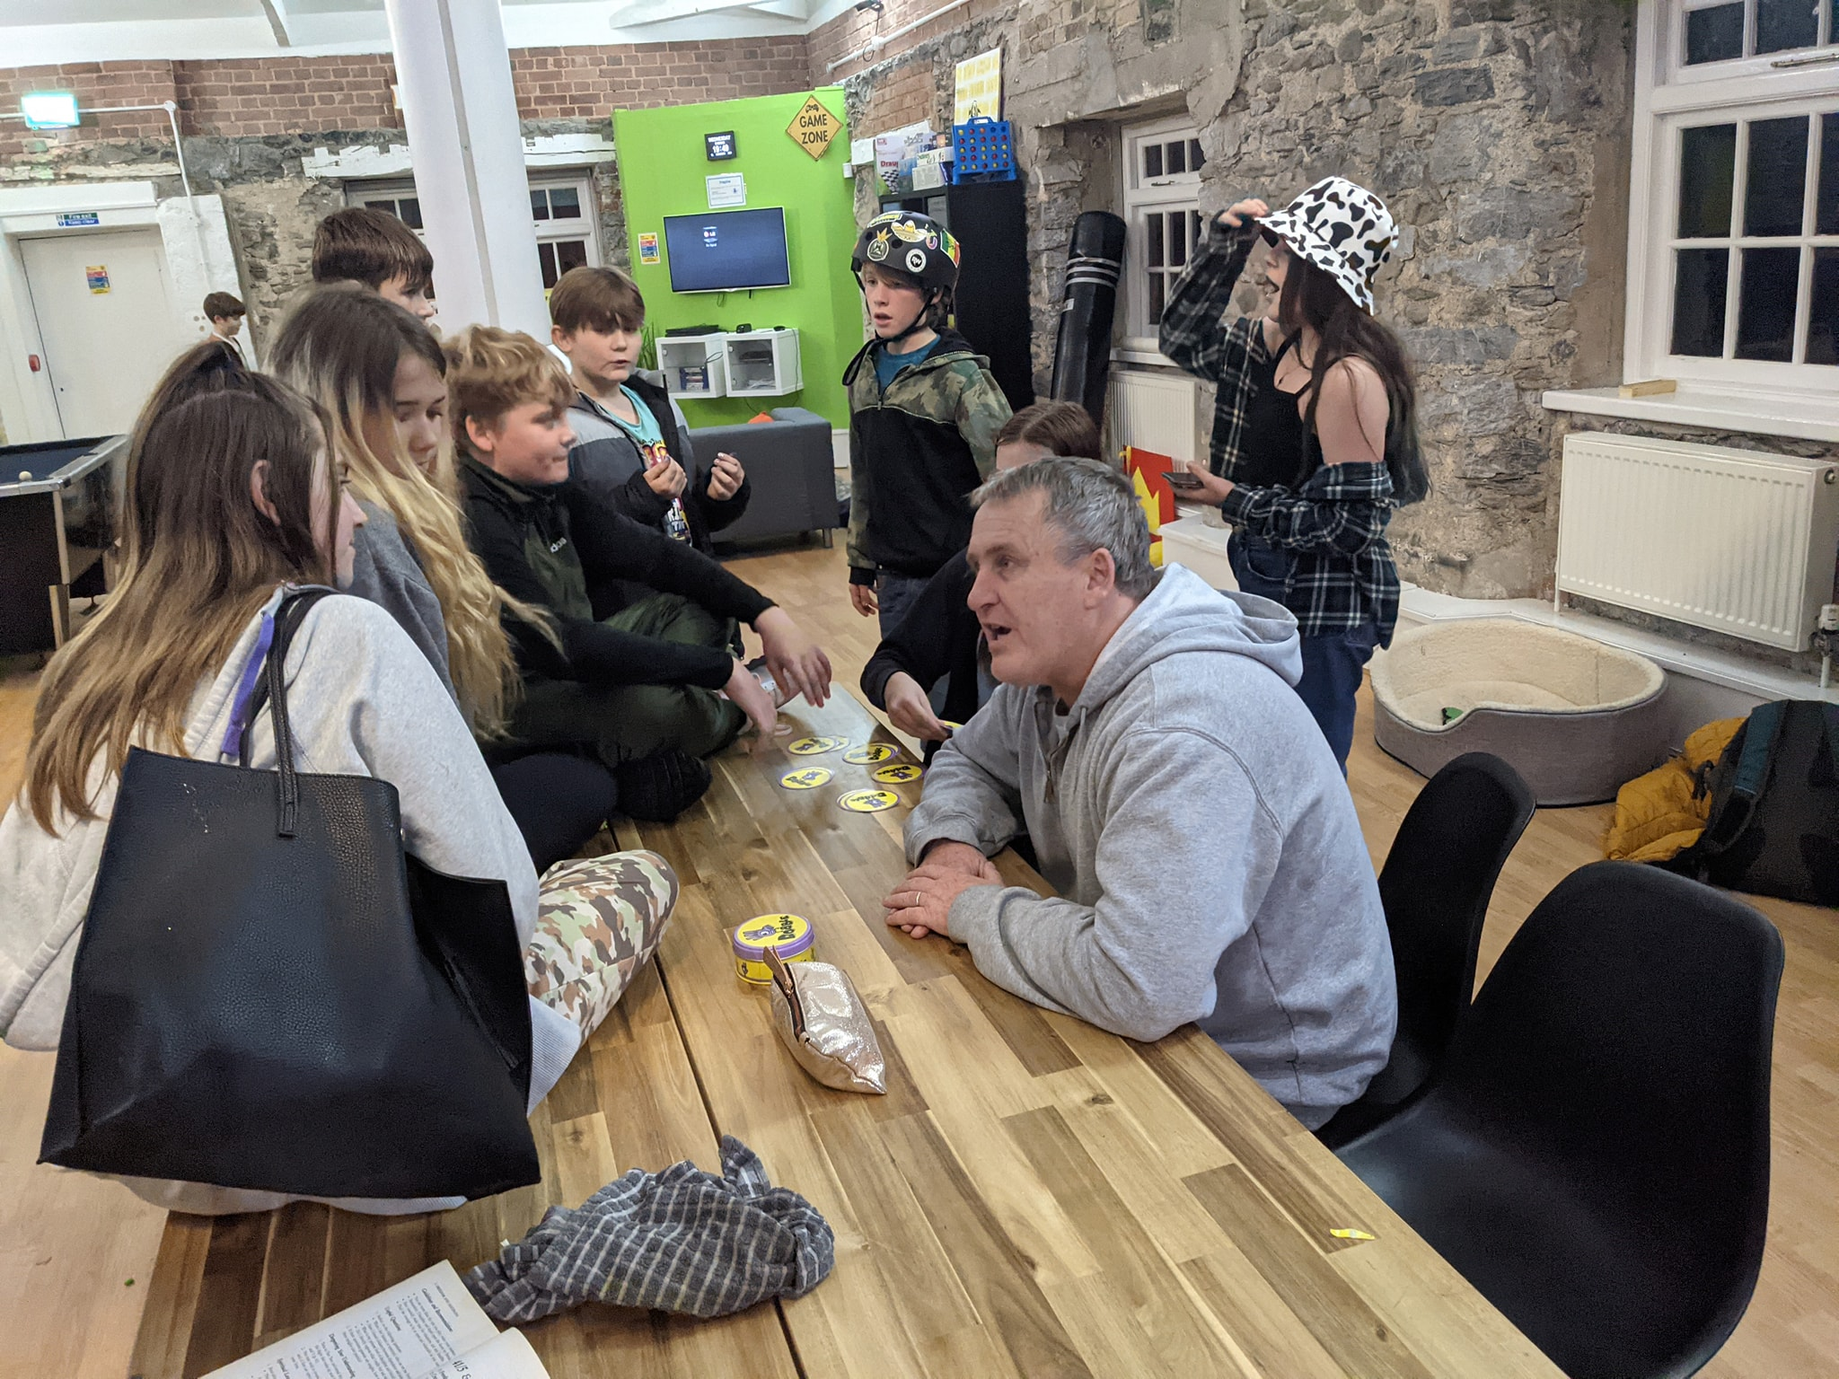

Thank you for your support, you have really helped us all and we have really enjoyed this project. Alyssa.

