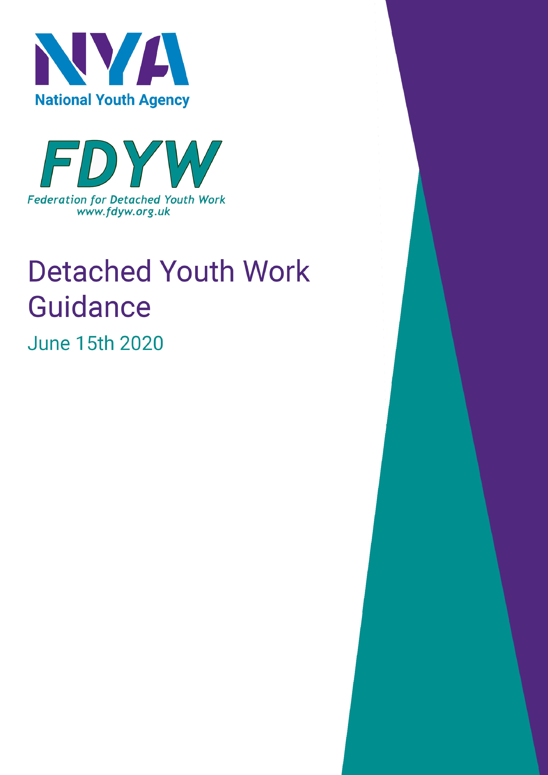

To minimise risk of young people contracting COVID-19 | To minimise risk of youth workers contracting COVID-19
Be clear about your intention when doing detached youth work | Wash hand immediately before and after sessions
Makes sure what you say about social distancing, physical contact, and safe hygiene is consistent and responsive to young people‘s questions and comments. Model good behaviour | Use Personal Protective Equipment (PPE) i.e. face covering, gloves, hand sanitiser. Wipe phones to reduce transmission risk
Be aware of the current regulations for COVID-19 and think of strategies to talk these through with young people in order to limit risks (a ‘walk and talk’ strategy may be useful) | Arrive and leave in separate vehicles and avoid public transport where possible. If you need to car share, where a mask.
Limit the types of activities that may require the passing objects. Provide information that can be given away rather than ask for it back | Staff working at a safe practical distance from one another and young people. Try not to become a focal point for groups gathering
Continue an open dialogue with young people about the formation of groups and any local by-laws and legislation about gathering | Ideally, wash all clothes and shower upon return home

Risk assessment:
Organisation name: Totnes Rural Area Youth Engagement (TRAYE) Assessment carried out by: Kerry McCabe (Project Lead and Coordinator)
Date of next review: 23/10/20 Date assessment was carried out: 23/07/20

What are the hazards? | Who might be harmed and how? | What are you already doing to control the risks? | What further action do you need to take to control the risks? | Who needs to carry out the action? | When is the action needed by? | Done
Hot weather | Workers and young people  Dehydration and sunstroke | Carrying sunscreen  Bottles of water | Advise to wear head gear  Move to shaded area  Activities short with more rests and water stops | All Workers | Start of session
Aggressive or Violent behaviour | Workers and young people  Physical or verbal attacks on individuals | Observing behaviour before entering area. Always have mobile phone and ID at hand  Make sure you and co-worker are always in sight of each other | Work in pairs  Management and Police know days and times detached team working  Conflict resolution skills if appropriate  Know your limitations  Walk away if you feel unsafe | All Workers | Throughout session
Trips and slips | Youth workers | Assess area before entering, walking etc. | First Aid kit available and at least one first aid trained worker | All Workers | Throughout session

 | Pavements, rough ground, unstable area giving way etc. | Sturdy footwear | Do not take risks  Read and understand safety and policy procedures of your organisation | All Workers | At beginning of session
Covid  Symptoms | All  Sneezing, coughing, touching | Wear mask when in enclosed space  Practice social distancing  Wash hands at every opportunity and hand sanitiser to use regularly | Open conversation with young people about distance and washing hands  Take care not to touch people or surfaces  Cough or sneeze into mask or arm | All Workers | Throughout session.
Physical contact | All  Hand on arm or hug etc.  Food and Money  First Aid | Observe behaviour and actions Keep at a distance from young people  Read and understand safeguarding policy  No food will be shared during Outreach/ Picnics  Sessions will not require a donation, there will be no handling of money.  First Aid Kit and PPE will be carried by workers at all times. | Make certain community recognise you and your work  Police knowledge of teams’ work  Be aware of others view of you  Young people will be told to bring their own packed lunch, blanket and drink when meeting outside with youth workers.  No donations will be taken from young people or their parents and carers.  If a young person hurts themselves and it is not an emergency, youth workers will instruct the young person to use the First Aid Kit by themselves. If a young person hurts themselves more severely, youth workers will use PPE provided to give First Aid treatment to the young person. If a young person require emergency medical treatment, youth workers will attend to them and call 999. | All Workers | Throughout session
Lack of light | Workers  Losing way, put in vulnerable position  Inciting fear in others | Always have a torch with you  Emergency call out available  Choose routes you know and are familiar with | Reconnaissance of new routes and new group hangouts  Assess areas new to you  Encourage groups to talk to you under streetlight if available | All Workers | Throughout session
Crowding | All  Spreading virus to each other  Police could move them on and give fines  Social distancing measures and rules on who you can meet | Role model  Social distancing  Discussion about why it  matters for their families/friends  Ideas for methods of talking and fun at a distance | Manager to have had discussion with Police  Knowledge and understanding of your work  Cards to give out explaining  COVID-19 info | All Workers | Throughout session
Illegal actions | Young people | Observe before entering area, judge safety  Community knowledge about work  ID and emergency call available | Know your work policies on substance use etc.  Recognise that this is their space and walk away if you feel unsafe | All Workers | Throughout session

Reviewed 23/08/20 – By Kerry McCabe Project Lead

Reviewed 23/09/20 – By Kerry McCabe Project Lead

Reviewed 20/09/21 – By Kerry McCabe – TRAYE Manager.

Detached/ Outreach youth work kit list:

Identity card (to be worn/visible at all times).
Work mobile phone, fully charged with numbers for colleagues/manager
Contact details/cards/leaflets for young people, parents/carers, members of the community
List of emergency contact numbers (incl. out of hours numbers for local authority Multi-Agency
Safeguarding Hub (MASH), Children’s Social Care (CSC), and Early Help (EH))

Torch
Personal alarm
Paper and pen (for you and your team)
Camera particularly if you are doing project work or want to record your interactions with young people (make sure to ask for their consent)

A wide range of young person-friendly information leaflets (e.g. local sexual health, mental health and other support services)

Activity resources (e.g. games, juggling balls, Frisbees, footballs)
Any items required for a specific session (e.g. team session plans, debrief forms, evaluation sheets, risk assessment forms)

For COVID-19 context:
Permission to work slip/letter from your trustees
PPE (as directed by your organisation/local authority)
Supply of gloves
Face coverings
Hand sanitiser
Wet wipes
Tissues
Sealable plastic bags (to secure used PPE)
Multiples of anything you typically use/may give to young people to use. (e.g. more paper and pens so you can give them away rather than collect in)

Local mutual/council information leaflets/publicity

At the end of the session, ask:

Have all recordings and evaluation procedures been completed?
Have all staff had a chance to discuss their views/feelings about session?
Have financial records been completed and receipts collected?
Does everyone know the plan for the next session; what will happen; who is responsible for what; etc?

Preparation for future sessions

Information for young people about meeting times, costs etc.
Consent forms/information for parents/carers

